Orchard Family Practice
(Practice Number 477) QOF Evidence 2015/16
PATIENT EXPERIENCE DOMAIN (PE001)

Summary Report:

During November 2015 we carried out our Patient Experience Survey.
- To meet the quota required to fulfil the survey we had to survey at least 2% of our population.
- Our current population in November 2015 was 4820.
- 2% - our target number was 96 completed surveys (or at least 50 responses)
- We circulated 96 surveys of which 84 were returned.

The total number of competed surveys returned was 84
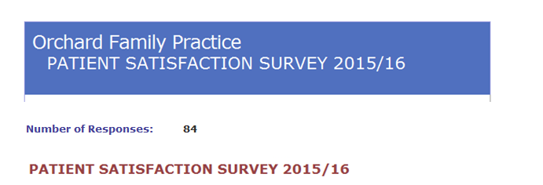

How did we contact patients?
We choose several methods of contacting patients in an effort to assure ourselves that we did not disproportionally affect returns for any particular group.

Firstly, we did make some efforts to split surveys between male and female 47% of completed returns were from males and 52% from females.

Prior to starting the survey we spent some time considering how we would encourage responses from all groups of patients. In an effort to ensure appropriate responses we split the questionnaires into 2 groups.

Total
58 (60%) of the total questionnaires issued were given to patients who were attending for a face-to-face consultation, questionnaires were given to all patients arriving for their appointment, during period of survey with some consideration of their age, disability & ethnicity. There were several forms which were completed with the help of the interpreting service for Northern Ireland.
Total
42 (40%) of the total questionnaires were further spilt:
- 19 (20%) to be given out to those patients who simply arrived at the desk for any other reason i.e. to collect a prescription
And;
- 19 (20%) were given to the Practice Manager who made arrangements to post surveys to a random selection of patients who had had a Telephone consultation (10 patients) or Home Visits (9 patients).

All patients were reassured of anonymity.

Face-to-Face surveys were given to patients on arrival for their appointment and a box was located on reception desk for patients to leave completed surveys before they left surgery.

Similarly patients, who arrived at reception to collect a prescription, were given a questionnaire and asked to complete and leave in box provided.

For the remaining group (Home Visits and Telephone Consultations) the Practice Manager posted the questionnaire to each patient and included an explanatory letter and a stamped addressed envelope for its return.

Once again each patient was assured of their anonymity.

The table below shows that we managed to obtain responses from a range of age groups across out practice population.

As per indicator PE001 Patient Experience, this survey included the recommendation question:
“Would you recommend your GP practice to someone who has just moved into the local area?”

TABLE SHOWS THE PERCENTAGE OF PATIENTS WHO GAVE EACH POSSIBLE CATEGORY OF RESPONSE:
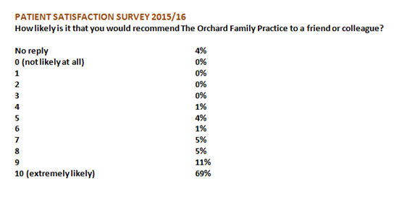
On our scale of 1 to 10 – 95% of patients agreed that they would be likely to recommend our practice to others. This was an extremely positive result with which we are very pleased.
TABLE BELOW SHOWS PATIENT FEEDBACK:
“Appointments are relatively easy to obtain and are allocated in relation to need which is good.
Extra appointments could be easily built in when a translator is required.
Repeat prescriptions works very well.
Reception and consultation is conducted in a “user friendly” way.”
“Ability to get an appointment within (often the same day) a suitable timeframe is something appreciated compared with other facilities in other towns.”
“Absolutely brilliant practice. 1st class.”
“All doctors very approachable. Great practice.”
“Are some doctors sick as the patients – no smiles”
“Doctor is very good.”
“Doctors don’t listen to patients.”
“Don’t think reception staff should ask about ailments prior to appointments, as should be between doctor and patient – seems like the doctor has to read up on it or something.”
“Easy to get an appointment - very friendly staff.2
“Excellent staff and doctors.”
“Helpful friendly staff from receptionist’s nurses and doctors. Never had a problem getting an appointment and this is a big help.”
“I always find doctors and reception staff extremely helpful and friendly.”
“I am enjoying quite good health, hence I am not seeing my GP quite often.”
“I am very pleased with this practice. The staff are very good.”
“I am very satisfied with any treatment/availability I have received in the past. Staff friendly and efficient. Good range of staff at all times. No concerns.”
“I appreciate the time our doctors take with us, the fact that we can get an appointment on the same day if necessary is crucial and I hope that doesn’t change.”
“No complaints. Can always get an appointment. Staff are very helpful.”
“No, just think that this is great practice, so friendly and caring.”
“Prefer Dr Williamson to other doctors in the practice.”
“Reception staff are brilliant.”
“Relatively easy access to GP. Excellent caring service”
“Sometimes it is hard to get an appointment.”
“Staff courteous. Diabetic clinic especially Nurse Millar who is exemplary.”
“The reception girls are first class very helpful.”
“The staff and doctors are all very kind to me. I thank them very much.”
“The doctors are excellent. The clinic is clean and very friendly.”
“The staff are friendly and very accommodating. Pleasant and cheerful. The GP is very good and very understanding (Dr Williamson) and always makes time to listen and is helpful and caring. I find the overall service is great. Thank you!!”
“Very friendly and helpful staff. I have no problems.”
“Very friendly staff.”
“Very happy with the friendly and warm hearted approach adapted by reception staff. Also the professional and sympathetic help from all the doctors. “
“Very pleased with the Emergency appointment system as can always get an appointment when I really need one.”
“We have problems with the amount of Coeliac food we can get on prescription. You are very strict about amounts allowed and I have friends in other practices who are able to get lots more on prescription. The food is expensive for us and it is a life-long condition. You should be a little more considerate!”

PATIENT COMMENTS:
Of the 32 patient comments 30 were extremely positive.
In response to the comment re: Coeliac Foods I will refer to the HSCB guidance document from Mr Joe Broggan Assistant Director of Integrated Care – Pharmacy & Medicines Management, which was circulated to all N.I. Practices, see link,
Prescribing Gluten Free Products Nov.11

In summary the practice follows this guidance which is detailed below:

HSCB Position on Gluten-Free Prescribing
- Confirmed ACBS-recognised diagnosis.
- Recommended quantities should not be exceeded - maximum one month’s supply at a time.
- Only bread, simple pasta, crackers, bread mix, flour mix and flour should be supplied on prescription.
- Items which are not consistent with healthy eating advice such as biscuits, cakes, muffins, pasties, sausage rolls should not be supplied on NHS prescription.

In line with the guidance each patient is allocated a defined number of “units” each month and each item prescribed has a unit value.

Unfortunately we cannot exceed the allocated unit value of a patient’s prescription.
Additional information is provided on the Coeliac.co.uk website (see above link in Mr Broggan’s letter).

With regard to other patient’s being prescribed a lot more products, we would expect that excessive prescribing of these products will be addressed directly with the practice by the H&SCB during the Annual Prescribing Review Meeting.

How did we communicate results & feedback to patient’s:
This report has been published on our practice website (as per our statement to patients on the initial questionnaire).

ACTION REQUIRED:
No further action required

